Selected development framework :

* Microsoft visual community 2015
* Microsoft Visual Studio 2013

Used library : OpenCV 3.0

Required definitions for project:

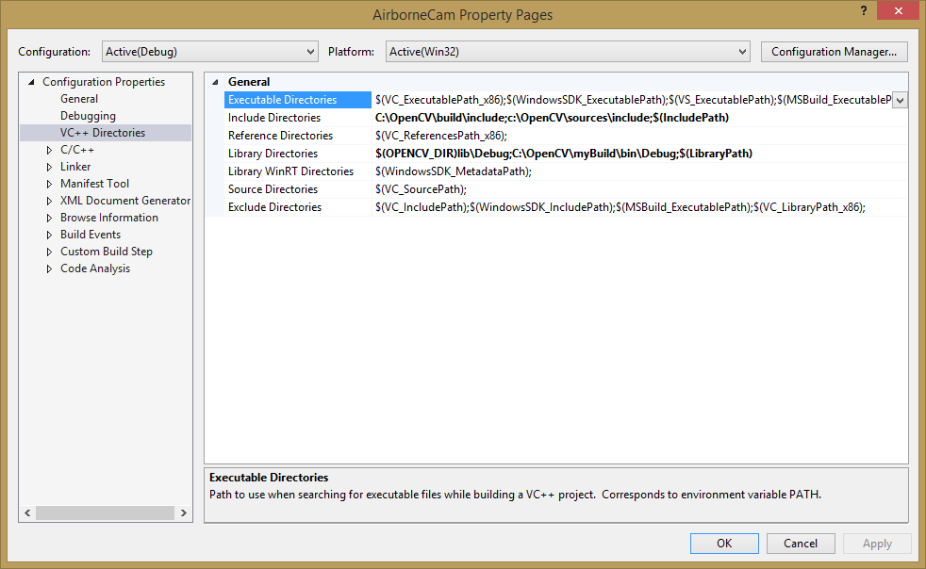

*Include directories :* C:\OpenCV\build\include;c:\OpenCV\sources\include;$(IncludePath)

*Library directories :* $(OPENCV_DIR)lib\Debug;C:\OpenCV\myBuild\bin\Debug;$(LibraryPath)

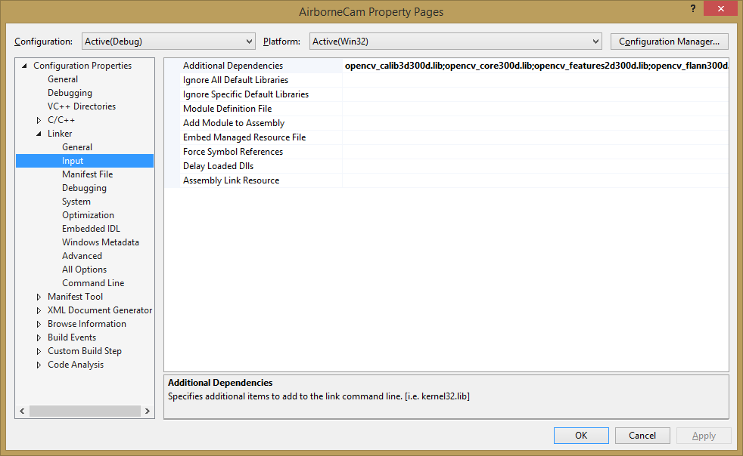

*Linker->Input :*

opencv_calib3d300d.lib;opencv_core300d.lib;opencv_features2d300d.lib;opencv_flann300d.lib;opencv_hal300d.lib;opencv_highgui300d.lib;opencv_imgcodecs300d.lib;opencv_imgproc300d.lib;opencv_ml300d.lib;opencv_objdetect300d.lib;opencv_photo300d.lib;opencv_shape300d.lib;opencv_stitching300d.lib;opencv_superres300d.lib;opencv_ts300d.lib;opencv_video300d.lib;opencv_videoio300d.lib;opencv_videostab300d.lib;%(AdditionalDependencies)

( those DLLs are located in the Library directories mentioned above )